A
Mini Project Report on

FEE PAYMENT TRACKER DASHBOARD AND PREDICTION

A Data Analytics & Business Intelligence Approach Using Excel and Power BI
A Real-Time Mini Project Report
Submitted in partial fulfilment of the Requirements for the Award of the Degree of

BACHELOR OF TECHNOLOGY IN COMPUTER SCIENCE AND ENGINEERING
By

GOPIDI RISHITHA (23TQ1A0530) BANOTH RAJENDAR (24TQ5A0505) N MAHESH (24TQ5A0502)
K SAI KUMAR (24TQ5A0507)

Under the Esteemed Guidance of
Ms.VIJAYATA RAMATEKE
Assistant Professor, Department of CSE


DEPARTMENT OF COMPUTER SCIENCE AND ENGINEERING SIDDHARTHA INSTITUTE OF TECHNOLOGY & SCIENCES (UGC-AUTONOMOUS)
(Approved by AICTE, New Delhi & Affiliated to JNTUH, Hyderabad) Accredited by NBA and NAAC with 'A+' Grade
Narapally, Korremula Road, Ghatkesar, Medchal-Malkajgiri (Dist)-500 088
2023 - 2027

CERTIFICATE
This is to certify that the project work entitled

"FEE PAYMENT TRACKER DASHBOARD AND PREDICTION"

By

GOPIDI RISHITHA (23TQ1A0530) BANOTH RAJENDAR (24TQ5A0505) N MAHESH (24TQ5A0502)
K SAI KUMAR (24TQ5A0507)

This is to certify that the project work entitled “Fee payment tracker dashboard and prediction” is a bonafide record of project work done jointly by N Mahesh (24TQ5A0502), K Sai Kumar (24TQ5A0507), Gopidi Rishitha (23TQ1A0530), B Rajendar (24TQ5A0505) under my guidance and supervision and is submitted in partial fulfilment of the requirements for the award of the Degree of Bachelor of Technology in Computer Science and Engineering by Jawaharlal Nehru Technological University Hyderabad (JNTUH), Hyderabad, during the academic year 2025-26.

PROJECT GUIDE HEAD OF THE DEPARTMENT

Ms.VIJAYATA RAMATEKE DR. SHIRISHA
Assistant Professor, Department of CSE Professor & HOD, Department of CSE

DECLARATION

We, N Mahesh (24TQ5A0502), K Sai Kumar (24TQ5A0507), Gopidi Rishitha (23TQ1A0530), B Rajendar (24TQ5A0505), hereby declare that the project work embodied in this report entitled “Fee payment tracker dashboard and prediction” has been carried out by us during the academic year 2023 - 2027 in partial fulfilment of the requirements for the award of the Degree of Bachelor of Technology in Computer Science and Engineering from Siddhartha Institute of Technology & Sciences, under the guidance of Ms.Vijayata Ramateke, Assistant Professor, Department of CSE. We further declare that this report is an authentic record of our own work and has not been submitted elsewhere for the award of any other degree or diploma.

By

GOPIDI RISHITHA (23TQ1A0530) BANOTH RAJENDAR (24TQ5A0505) N MAHESH (24TQ5A0502)
K SAI KUMAR (24TQ5A0507)

ACKNOWLEDGEMENT
We would like to express our sincere gratitude to our project guide Ms.Vijayata Ramateke, Assistant Professor, Department of CSE, for his valuable guidance, constant encouragement, and constructive suggestions throughout the course of this project.
We express our heartfelt thanks to Dr. Shirisha, Head of the Department, Computer Science and Engineering, for her valuable support and encouragement in completing this project successfully.
We convey our profound sense of gratitude to our Principal Dr. M. Janardhan, for providing an excellent academic environment and extending his support at every stage to help us accomplish our task successfully.
We would like to express our deepest gratitude and sincere thanks to Smt. V. Jyothi, Director & Chairperson, Siddhartha Institute of Technology & Sciences, Narapally, Hyderabad (UGC Autonomous) for her constant encouragement and support in providing all the necessary facilities to carry out this project work.
Finally, we extend our sincere thanks to all the faculty members and supporting staff of the Department of Computer Science and Engineering, and our friends, for their cooperation and encouragement throughout the completion of this project.

PROJECT ASSOCIATES GOPIDI RISHITHA (23TQ1A0530) BANOTH RAJENDAR (24TQ5A0505) N MAHESH (24TQ5A0502)
K SAI KUMAR (24TQ5A0507)

LIST OF FIGURES

Figure No. | Name of the Figure | Page No.
Figure 3.1 | Project Workflow of the Fee Collection Tracker | 5
Figure 3.2 | Sample SQL Query for Fee Summary | 6
Figure 4.1 | Fee Collection Tracker – Power BI Dashboard (Overview) | 8
Figure 4.2 | Key Performance Indicator (KPI) Cards | 8
Figure 4.3 | Fee Collection Trend, Course-wise Collection and Payment Status Charts | 9
Figure 4.4 | Student Fee Summary, Pending Fees by Course and Monthly Collection Table/Charts | 9

LIST OF TABLES

Table No. | Name of the Table | Page No.
Table 2.1 | Summary of Literature Review | 3
Table 3.1 | Dataset Structure / Fields Used in the Project | 5
Table 3.2 | Hardware Requirements | 7
Table 3.3 | Software Requirements | 7
Table 4.1 | Key Performance Indicators – Fee payment tracker dashboard and prediction | 8
Table 4.2 | Course-wise Fee Collection Summary | 9

LIST OF ABBREVIATIONS

Abbreviation | Full Form
SQL | Structured Query Language
BI | Business Intelligence
KPI | Key Performance Indicator
DAX | Data Analysis Expressions
CSV | Comma-Separated Values
UI | User Interface
INR | Indian Rupee
DB | Database
ID | Identification
IT | Information Technology

TABLE OF CONTENTS

TITLE | PAGE NO
Certificate | ii
Declaration | iii
Acknowledgement | iv
Abstract | v
List of Figures | vi
List of Tables | vii
List of Abbreviations | viii
Chapter 1: Introduction | 1
1.1 Introduction to Fee Collection Management | 1
1.2 Existing System | 1
1.2.1 Disadvantages of Existing System | 1
1.3 Problem Statement | 1
1.4 Proposed System | 2
1.5 Objectives of the Project | 2
1.6 Organization of the Report | 2
Chapter 2: Literature Review | 3
2.1 Introduction | 3
2.2 Related Work / Existing Approaches | 3
2.3 Summary of Literature Review | 3
Chapter 3: Project Description / Methodology | 5
3.1 Overall Methodology | 5
3.2 System Architecture | 5
3.3 Dataset Description | 5
3.4 Data Cleaning Using Excel | 6
3.5 Data Storage and Analysis Using SQL | 6
3.6 Dashboard Development Using Power BI | 7
3.7 Tools and Technologies Used | 7
3.8 Hardware and Software Requirements | 7
Chapter 4: Results and Discussion | 8
4.1 Dashboard Overview | 8
4.2 Key Performance Indicators | 8

TITLE | PAGE NO
4.3 Discussion of Results | 9
Chapter 5: Conclusion and Future Scope | 11
5.1 Conclusion | 11
5.2 Limitations | 11
5.3 Future Scope | 11
References | 12

ABSTRACT :
Educational institutions handle large volumes of student fee data every academic year, covering total fees, collected fees, pending dues, payment modes, and course-wise or department-wise collection performance. When such data is maintained manually or in scattered spreadsheets, it becomes increasingly difficult to track pending payments, identify collection trends, and generate timely reports for management decision-making.
The Fee payment tracker dashboard and prediction is a data analytics and business intelligence project developed to address this problem. Microsoft Excel is used to collect, clean, and prepare the raw student fee data. SQL is used to store the structured data and perform queries such as aggregation, filtering, grouping, and joins to compute total, collected, and pending fee amounts. Microsoft Power BI is then used to build an interactive dashboard that visualizes this analyzed data through KPI cards, trend charts, donut charts, and detailed tables.
The resulting dashboard allows an administrator to monitor total fees, collected fees, pending fees, and the overall collection percentage at a glance, and to drill down by academic year, course, and payment status. It highlights course-wise fee distribution, monthly collection trends, payment status breakdown, and a detailed list of students with pending dues. This project demonstrates the practical application of data cleaning, SQL-based analysis, and Power BI visualization to convert raw institutional data into actionable insights that support faster reporting and more informed, data-driven decision-making.

Keywords :

- Fee Collection Tracker,

- Data Analytics,

- SQL, Power BI,

- Microsoft Excel,

- Data Cleaning,

- Business Intelligence,

- Fee Management,

- Data Visualization.

CHAPTER 1 INTRODUCTION

INTRODUCTION TO FEE PAYMENT TRACKER MANAGEMENT
Fee collection is one of the most routine yet critical financial activities carried out by every educational institution. It directly affects the institution's cash flow, budgeting, and overall financial planning. Every academic year, institutions collect fees from a large number of students across different courses, departments, and academic years, and must simultaneously track how much has been collected, how much remains pending, and which students still owe payments.
As the number of students enrolled in an institution increases, manually tracking this information using spreadsheets or paper registers becomes time-consuming and error-prone. Administrative staff often struggle to answer simple but important questions quickly, such as the total fee pending for a particular course, or which students have not paid their dues for the current semester. This project, the Fee Collection Tracker, was developed to address this gap by combining Excel, SQL, and Power BI into a single structured pipeline that transforms raw fee records into an interactive, easy-to-read dashboard.

EXISTING SYSTEM
In most small and mid-sized educational institutions, student fee records are currently maintained using basic Excel spreadsheets or manual paper-based registers. Fee details such as total fee, amount paid, and payment dates are entered by administrative staff as and when a transaction takes place. Reports, when required, are prepared manually by going through these records and calculating totals using basic spreadsheet formulas.

Disadvantages of Existing System
      - Manual entry increases the chances of duplicate records, missing values, and incorrect fee calculations.
      - There is no centralized database, making it difficult to consolidate data across departments and courses.
      - Generating reports such as monthly collection trends or department-wise pending fees requires significant manual effort.
      - It is difficult to quickly identify students with long-pending dues without going through the entire dataset.
      - The existing system does not provide any visual or interactive way to analyze collection performance over time.
      - Decision-making is delayed as management has to wait for manually compiled reports.

PROBLEM STATEMENT
Educational institutions often maintain student fee information using Excel sheets or manual records. As the number of students increases, it becomes difficult to accurately track total fees assigned, fees already collected, remaining or pending fees, student-wise payment history, monthly fee collections, course-wise fee collections, students who have not paid their fees, and overall payment status and collection performance. Manual tracking can also result in duplicate records, incorrect calculations, missing values, and difficulty in generating timely reports. There is, therefore, a need for a centralized fee collection tracking and visualization system.

PROPOSED SYSTEM
The proposed Fee Collection Tracker replaces manual fee tracking with a structured, three-stage analytics pipeline. Raw student fee data is first collected and cleaned using Microsoft Excel, which handles duplicate removal, missing-value treatment, and formatting. The cleaned data is then loaded into a SQL database, where structured queries are used to compute total, collected, and pending fee amounts, and to generate course-wise, department-wise, and month-wise summaries. Finally, the SQL output is connected to Microsoft Power BI, where an interactive dashboard is built using KPI cards, charts, slicers, and detailed tables, allowing administrators to monitor and analyze fee collection performance in real time.

OBJECTIVES OF THE PROJECT
- To organize student fee data in a structured and consistent format.
- To clean and pre-process raw fee collection data using Microsoft Excel.
- To store and manage the structured fee data using SQL.
- To calculate total, collected, and pending fee amounts accurately.
- To identify students with outstanding or partially paid fees.
- To analyze fee collection trends by month, course, and payment status.
- To design and develop an interactive Power BI dashboard for fee collection monitoring.
- To provide management with quick, accurate, and visual financial insights.

ORGANIZATION OF THE REPORT
The remainder of this report is organized as follows. Chapter 2 presents a review of existing approaches related to fee tracking, data cleaning, and dashboard-based reporting. Chapter 3 describes the overall methodology, system architecture, dataset, and the tools and technologies used to build the Fee Collection Tracker. Chapter 4 presents the results obtained, including the Power BI dashboard, key performance indicators, and a discussion of the insights generated. Chapter 5 concludes the report with a summary of the work, its limitations, and directions for future enhancement.

CHAPTER 2 LITERATURE REVIEW

INTRODUCTION
This chapter presents a review of the general approaches followed by educational institutions and organizations for fee or payment tracking, and the common data-handling and reporting techniques used in such systems. Since fee collection tracking is essentially a data management and business intelligence problem, this review focuses on the three broad areas relevant to the project: spreadsheet-based record keeping, relational-database-based analysis, and dashboard-based business intelligence reporting.

RELATED WORK / EXISTING APPROACHES
Spreadsheet-based tracking. The most common approach followed by small and medium institutions is to maintain fee records in Microsoft Excel. Excel offers formulas, pivot tables, and basic charts that allow limited analysis, such as computing totals or simple trend lines. However, as the volume of data grows, spreadsheets become difficult to maintain, are prone to manual errors, and do not scale well when multiple users need to update or query the data simultaneously.
Database-driven tracking. A more structured approach involves storing fee records in a relational database using SQL. This allows data to be queried using aggregation, filtering, grouping, and join operations, which makes it possible to generate summaries such as total collection by department or course, and to enforce data consistency through defined table structures and relationships. This approach is more scalable than spreadsheets but, on its own, still requires technical knowledge (SQL queries) to extract insights, and does not provide a visual interface for non-technical staff.
Business intelligence (BI) dashboards. Business intelligence tools such as Power BI, Tableau, and similar platforms allow structured data from databases or spreadsheets to be transformed into interactive visual dashboards. These dashboards typically include KPI cards, trend charts, and slicers/filters that let users explore data without writing queries. This approach is increasingly being adopted across sectors, including education, finance, and healthcare, for management reporting because it combines the analytical power of structured data with an accessible, visual interface for decision-makers.
The Fee Collection Tracker project builds on this general trend by combining all three layers, Excel for data preparation, SQL for structured storage and analysis, and Power BI for visualization, into a single coherent pipeline specifically applied to the problem of student fee tracking in an educational institution.

SUMMARY OF LITERATURE REVIEW
Table 2.1 summarizes the three broad approaches reviewed in this chapter, along with their respective strengths and limitations, as considered during the design of the proposed system.

Table 2.1: Summary of Literature Review

Approach | Strengths | Limitations
Spreadsheet-based tracking (Excel only) | Easy to use; low cost; familiar to most staff | Error-prone; hard to scale; limited analysis and visualization
Database-driven tracking (SQL only) | Structured storage; supports complex queries; consistent data | Requires technical/SQL knowledge; no visual interface
BI dashboard-based reporting  (Power BI) | Interactive visuals; accessible to non-technical users; real-time insights | Depends on clean, well-structured underlying data

[TO BE PROVIDED: If specific journal articles, conference papers, or reference textbooks were used or recommended by your guide, please provide their author names, titles, and publication details so they can be cited here and added to the References chapter.]

CHAPTER 3 METHODOLOGY

OVERALL METHODOLOGY
The Fee Collection Tracker follows a linear, three-stage data pipeline: data collection and cleaning, structured storage and analysis, and interactive visualization. Raw student fee data is first collected and cleaned in Microsoft Excel. The cleaned data is then imported into a SQL database, where it is queried and aggregated to compute fee summaries. Finally, the SQL output is connected to Power BI, where an interactive dashboard is designed to present the analyzed data to the end user (institution administrators or management).
The overall workflow can be summarized as:
Raw Data → Excel Cleaning → SQL Database → SQL Analysis → Power BI → Interactive Dashboard → Business Insights
Figure 3.1: Project Workflow of the Fee Collection Tracker

SYSTEM ARCHITECTURE
The system is organized into three functional layers, each responsible for a distinct part of the pipeline, as illustrated in Figure 3.1.

Layer 1: Data Preparation (Excel)
This layer is responsible for collecting raw student fee records and preparing them for structured storage. It handles data entry, removal of duplicate records, treatment of missing values, correction of formatting issues, and creation of calculated columns (such as pending fee).

Layer 2: Data Storage and Analysis (SQL)
This layer stores the cleaned data in relational database tables and performs structured queries to compute totals, group data by course/department/month, and identify students with pending or partially paid fees.

Layer 3: Visualization (Power BI)
This layer connects to the SQL output and presents the analyzed data through KPI cards, charts, slicers, and tables, allowing the end user to interactively explore the fee collection data without writing any queries.

DATASET DESCRIPTION
The dataset used in this project consists of student-level fee records, with each row representing one student's fee account for the academic year. Table 3.1 lists the fields used in the dataset.

Table 3.1: Fields Used in the Project

Column | Description
Student ID | Unique identification number of the student
Student Name | Name of the student
Course | Course enrolled by the student (B.Tech, MBA, BBA, BCA, MCA, etc.)
Academic Year | Academic year of the fee record
Total Fees | Total fee payable by the student
Collected Fees | Amount already paid by the student
Pending Fees | Remaining fee amount (Total Fees − Collected Fees)
Payment Status | Paid, Partial Paid, or Pending
Payment Date / Month | Date or month in which the payment was made

DATA CLEANING USING EXCEL
Before the dataset could be analyzed, it was checked and cleaned in Microsoft Excel. The cleaning process involved:
    - Removing duplicate student records.
    - Identifying and handling missing or blank fee values.
    - Standardizing course and payment-status labels for consistency.
    - Verifying that Pending Fees equals Total Fees minus Collected Fees for every record.
    - Formatting date fields consistently for month-wise analysis.
After cleaning, the standardized dataset was exported and imported into the SQL database for the next stage of analysis.

DATA STORAGE AND ANALYSIS USING SQL
The cleaned data was loaded into a SQL database table (Fee_Details) containing the fields described in Table 3.1. SQL queries were then written to compute the key figures required for the dashboard, such as overall totals, course-wise collection, and pending-fee lists. A representative query used to compute the overall fee summary is shown in Figure 3.2.

SELECT
SUM(Total_Fees) AS Total_Fees, SUM(Collected_Fees) AS Collected_Fees, SUM(Total_Fees - Collected_Fees) AS Pending_Fees,
ROUND(SUM(Collected_Fees) * 100.0 / SUM(Total_Fees), 2) AS Collection_Percentage
FROM Fee_Details;
Figure 3.2: Sample SQL Query for Fee Summary
Similar queries, using GROUP BY on Course and on Payment Month, were used to generate the course-wise and month-wise collection summaries used in the Power BI dashboard. The important calculations used throughout the project are:
Pending Fee = Total Fees − Collected Fees Collection % = (Collected Fees / Total Fees) × 100

DASHBOARD DEVELOPMENT USING POWER BI
The SQL query output was connected to Microsoft Power BI as the data source. Within Power BI, calculated measures were created using DAX to support the KPI cards and percentage-based visuals. The dashboard was then designed using the following visual components:
    - KPI cards for Total Fees, Collected Fees, Pending Fees, Collection %, Total Students, and Total Payments.
    - A line/area chart showing Collected Fees vs. Pending Fees over time.
    - A donut chart showing collection distribution by course.
    - A donut chart showing payment status distribution (Paid, Partial Paid, Pending).
    - A student fee summary table listing individual student records with payment status.
    - A bar chart showing pending fees by course.
    - A column chart showing month-wise collected fees.
    - Interactive filters/slicers for Academic Year, Course, Payment Status, and Date Range.

TOOLS AND TECHNOLOGIES USED
    - Microsoft Excel – data entry, cleaning, and pre-processing
    - SQL – structured data storage, querying, and aggregation
    - Microsoft Power BI – data visualization, DAX measures, and interactive dashboard design

HARDWARE AND SOFTWARE REQUIREMENTS

Table 3.2: Hardware Requirements

Component | Specification
Processor | Intel Core i3 / i5 or higher
RAM | Minimum 4 GB (8 GB recommended)
Storage | Minimum 10 GB free disk space
Display | Standard monitor, 1366 × 768 resolution or higher

Table 3.3: Software Requirements

Component | Specification
Operating System | Windows 10 / Windows 11
Spreadsheet Tool | Microsoft Excel
Database | SQL (relational database engine)
Visualization Tool | Microsoft Power BI Desktop

CHAPTER 4 RESULTS AND DISCUSSION

DASHBOARD OVERVIEW
The final outcome of the project is an interactive Fee Collection Tracker dashboard built in Power BI, connected to the cleaned and structured data prepared using Excel and SQL. The dashboard, shown in Figure 4.1, allows the user to filter data by Academic Year, Course, Payment Status, and Date Range, and provides a centralized view of the institution's fee collection performance for the academic year 2024-25.
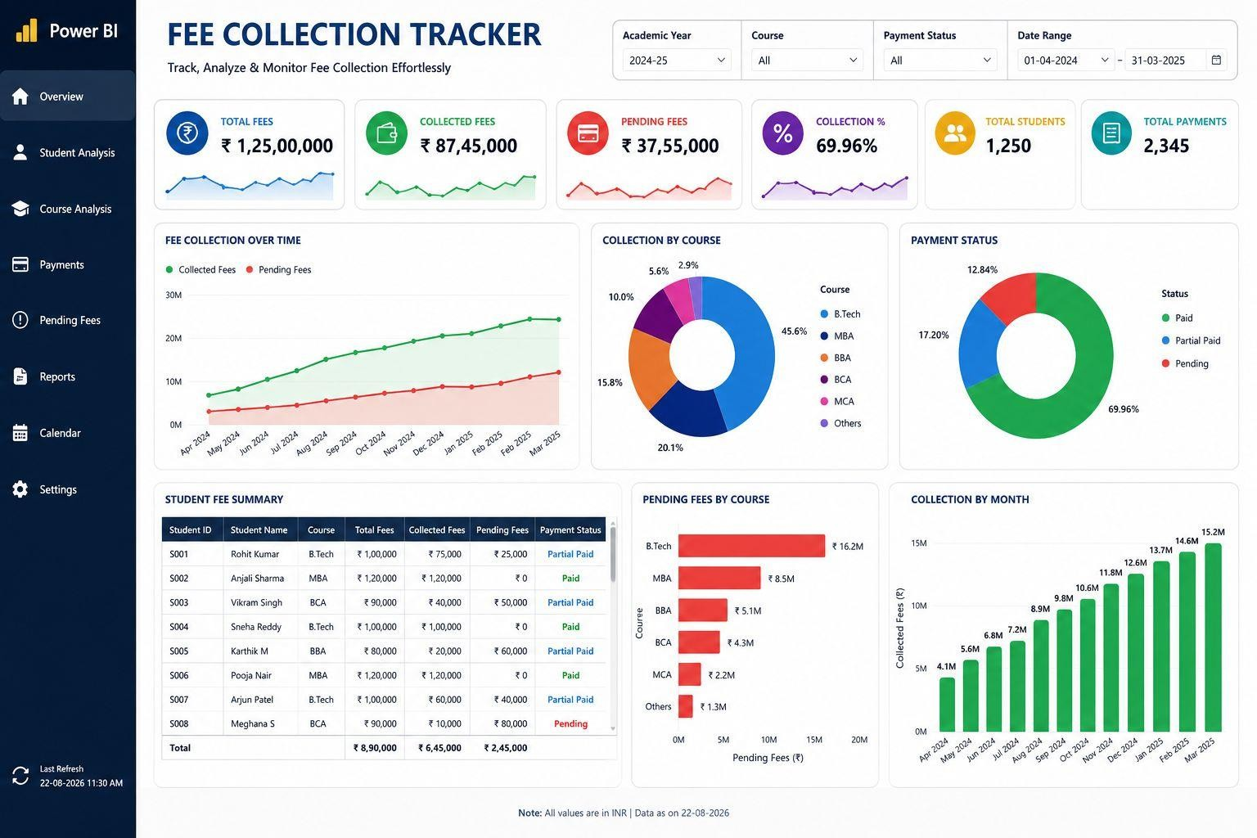
Figure 4.1: Fee Collection Tracker – Power BI Dashboard (Overview)

KEY PERFORMANCE INDICATORS
Table 4.1 summarizes the key performance indicators displayed on the dashboard for the academic year 2024-25 (data range 01-04-2024 to 31-03-2025).
Figure 4.2: Key Performance Indicator (KPI) Cards

Table 4.1: Key Performance Indicators – Fee Collection Tracker Dashboard

KPI | Value
Total Fees | ₹ 1,25,00,000
Collected Fees | ₹ 87,45,000
Pending Fees | ₹ 37,55,000
Collection Percentage | 69.96%
Total Students | 1,250
Total Payments (Transactions) | 2,345

Figure 4.3 shows the Fee Collection Over Time trend, the course-wise collection distribution, and the payment status breakdown.
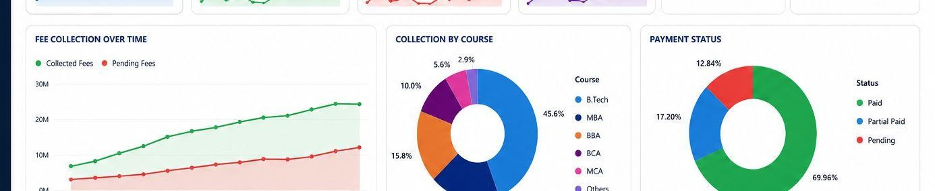
Figure 4.3: Fee Collection Trend, Course-wise Collection and Payment Status Charts

Table 4.2: Course-wise Fee Collection Summary

Course | Share of Collection | Pending Fees
B.Tech | 45.6% | ₹ 16.2M
MBA | 20.1% | ₹8.5M
BBA | 15.8% | ₹5.1M
BCA | 10.0% | ₹4.3M
MCA | 5.6% | ₹2.2M
Others | 2.9% | ₹1.3M

DISCUSSION OF RESULTS
Figure 4.4 shows the detailed student fee summary table, the pending-fees-by-course chart, and the month-wise collection chart.
The dashboard shows that, for the academic year 2024-25, 69.96% of the total fees due (₹1,25,00,000) had been collected, amounting to ₹87,45,000, while ₹37,55,000 remained pending

across 1,250 students. Of the total payment status distribution, the majority of records fall under “Paid” (69.96%), followed by “Partial Paid” (17.20%) and “Pending” (12.84%).

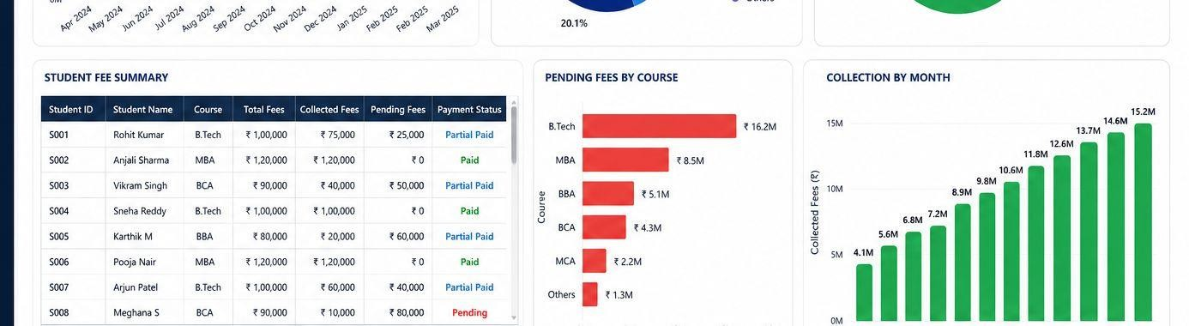
Figure 4.4: Student Fee Summary, Pending Fees by Course and Monthly Collection Table/Charts
Course-wise analysis shows that B.Tech accounts for the largest share of fee collection (45.6%), followed by MBA (20.1%) and BBA (15.8%). Correspondingly, B.Tech also carries the highest pending-fee amount (₹16.2M), indicating that the largest cohort of students also contributes the largest share of outstanding dues in absolute terms. The Fee Collection Over Time chart shows a steadily rising trend in collected fees from April 2024 through March 2025, while pending fees also show a gradual increase over the same period, suggesting that new dues are being added over time even as older dues are collected.
The student fee summary table allows administrators to identify individual students with pending or partially paid fees (for example, students with a “Pending” or “Partial Paid” status), enabling targeted follow-up. Overall, the dashboard demonstrates that combining Excel-based cleaning, SQL-based aggregation, and Power BI visualization can convert a raw, manually maintained fee register into a live, filterable reporting tool that supports faster and more accurate financial monitoring than the existing manual system described in Chapter 1.

CHAPTER 5 CONCLUSION AND FUTURE SCOPE

CONCLUSION
This project set out to replace manual, spreadsheet-based fee tracking with a structured and interactive analytics pipeline. Using Microsoft Excel, the raw student fee data was cleaned and standardized; using SQL, the cleaned data was stored and queried to compute total, collected, and pending fee figures at the overall, course-wise, and month-wise levels; and using Microsoft Power BI, an interactive dashboard was designed to present these results through KPI cards, trend charts, donut charts, and detailed tables.
The resulting Fee payment tracker dashboard and prediction successfully consolidates student fee information for the academic year 2024-25 into a single, filterable view, showing a total fee value of ₹1,25,00,000, a collection percentage of 69.96%, and detailed course-wise and student-wise breakdowns. This demonstrates that the objectives set out in Chapter 1, namely organizing fee data, automating its analysis, and visualizing it for quick decision-making, were achieved within the scope of this project.

LIMITATIONS
    - The dashboard currently reflects a static dataset for the 2024-25 academic year and is not connected to a live, continuously updating institutional database.
    - The system does not currently send automated reminders or notifications to students with pending fees.
    - Data cleaning and validation are performed manually in Excel and are not yet automated.

FUTURE SCOPE
The current system can be extended by integrating it with the institution's live student information system or ERP, so that the SQL database is updated automatically whenever a new payment transaction occurs, removing the need for manual data refreshes in Excel.
The dashboard can also be enhanced with automated alert mechanisms, such as email or SMS reminders sent to students whose payment status is “Pending” or “Partial Paid” beyond a certain due date, which would help institutions follow up on outstanding dues more proactively.
Finally, the analytical scope of the project can be broadened by incorporating predictive analytics, for example, using historical payment patterns to forecast which students are likely to default on future instalments, or by adding role-based dashboard views so that department heads see only their department's data while overall management retains the consolidated, institution-wide view.

REFERENCES

Reference / Hand Books
- Microsoft Corporation, “Power BI Documentation,” Microsoft Learn. [TO BE PROVIDED: exact URL/date accessed, if you wish to cite it]
- Microsoft Corporation, “Excel Functions and Formulas Reference,” Microsoft Support Documentation. [TO BE PROVIDED: exact URL/date accessed, if you wish to cite it]
- [TO BE PROVIDED: Add the SQL database platform's official documentation used, e.g., MySQL / SQL Server / PostgreSQL documentation, with version and URL.]
- [TO BE PROVIDED: Add any textbook, journal, or conference paper references recommended or approved by your project guide.]

